LUXCHEM CORPORATION BERHAD
(Company No: 224414-D)
(Incorporated in Malaysia)

QUARTERLY FINANCIAL REPORT AS AT 30 JUNE 2009

The Board of Directors of Luxchem Corporation Berhad (“LCB” or “the Company”) is pleased to announce the following unaudited consolidated results of LCB and its subsidiaries (collectively known as “the Group”) for the second quarter ended 30 June 2009.

The Company is principally involved in investment holding while the subsidiaries of the Company are principally involved in the marketing and distribution of industrial chemicals and materials and the manufacture of Unsaturated Polyester Resins.

UNAUDITED CONDENSED CONSOLIDATED INCOME STATEMENT

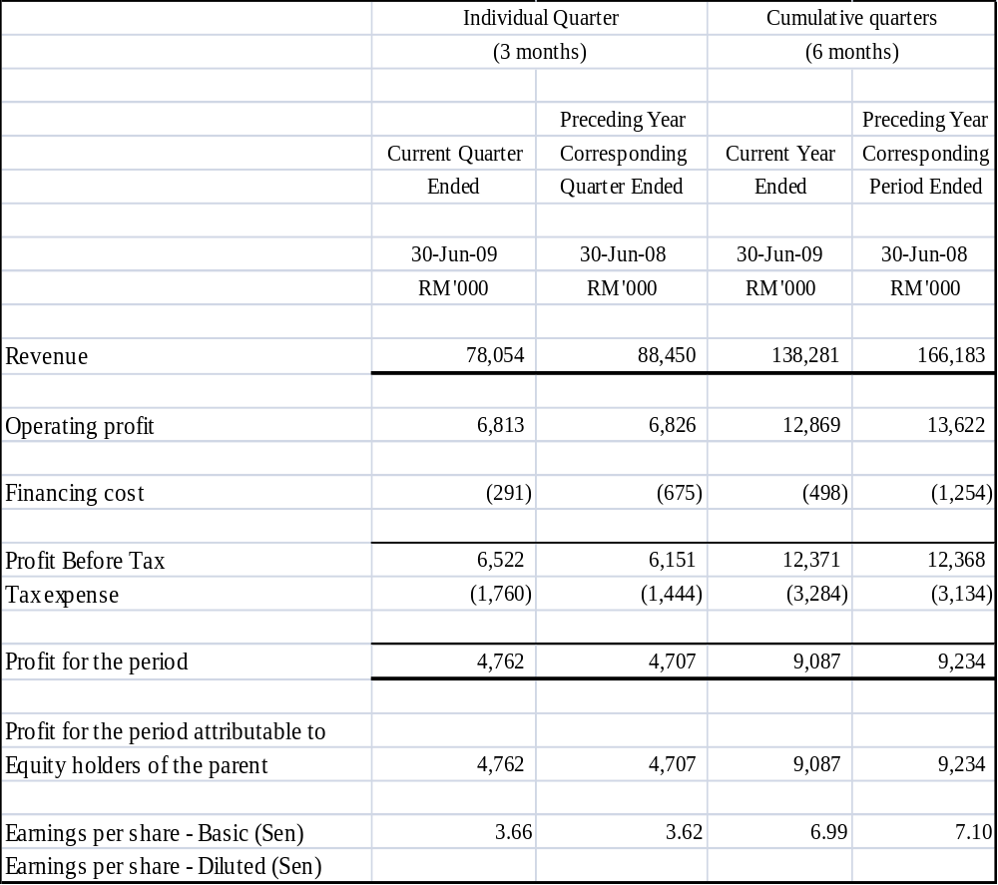

Notes:
- The condensed consolidated income statement should be read in conjunction with the audited financial statements for the financial year ended 31 December 2008 and the accompanying explanatory notes attached to the quarterly financial report.

LUXCHEM CORPORATION BERHAD
(Company No: 224414-D)
((Incorporated in Malaysia)

QUARTERLY FINANCIAL REPORT AS AT 30 JUNE 2009
CONDENSED CONSOLIDATED BALANCE SHEET

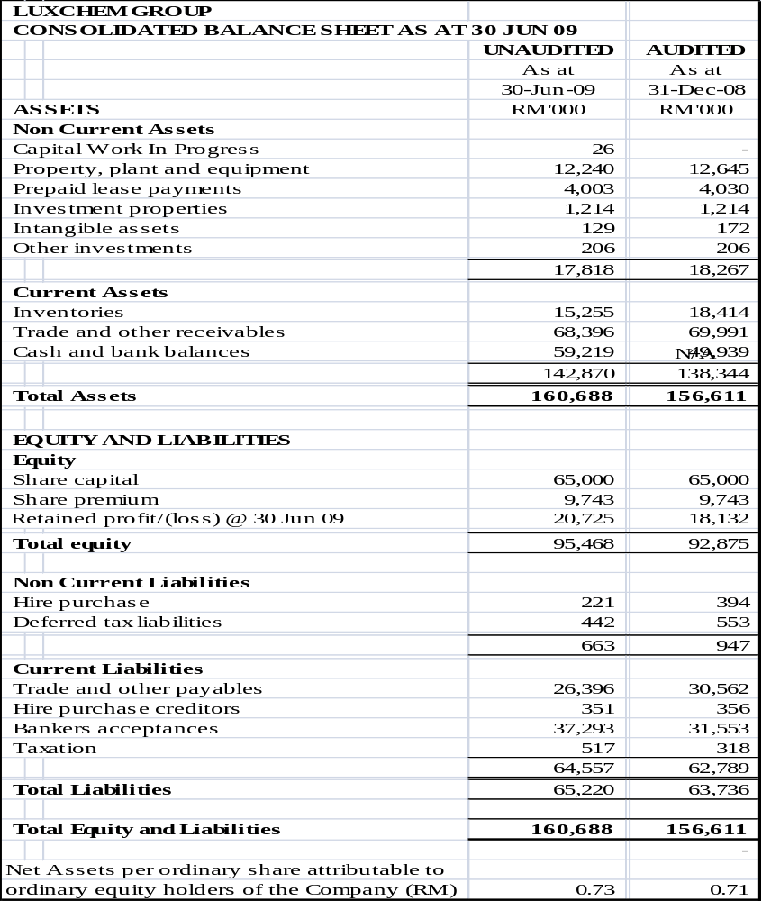

The condensed consolidated balance sheet should be read in conjunction with the audited financial statements for the financial year ended 31 December 2008 and the accompanying explanatory notes attached to the quarterly financial report.
LUXCHEM CORPORATION BERHAD
(Company No: 224414-D)
(Incorporated in Malaysia)

QUARTERLY FINANCIAL REPORT AS AT 30 JUNE 2009

UNAUDITED CONDENSED CONSOLIDATED CASH FLOW STATEMENT
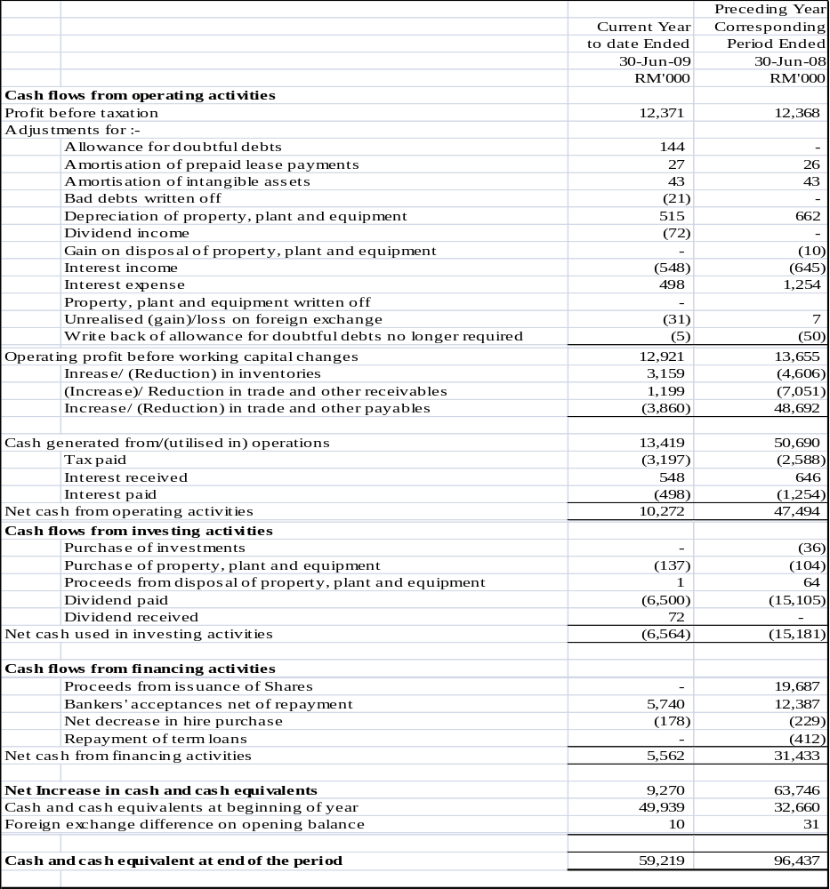

The condensed consolidated cash flow statement should be read in conjunction with the audited financial statements for the financial year ended 31 December 2008 and the accompanying explanatory notes attached to the quarterly financial report.

LUXCHEM CORPORATION BERHAD
(Company No: 224414-D)
(Incorporated in Malaysia)

QUARTERLY FINANCIAL REPORT AS AT 30 JUNE 2009

UNAUDITED CONDENSED CONSOLIDATED STATEMENT OF CHANGES IN EQUITY

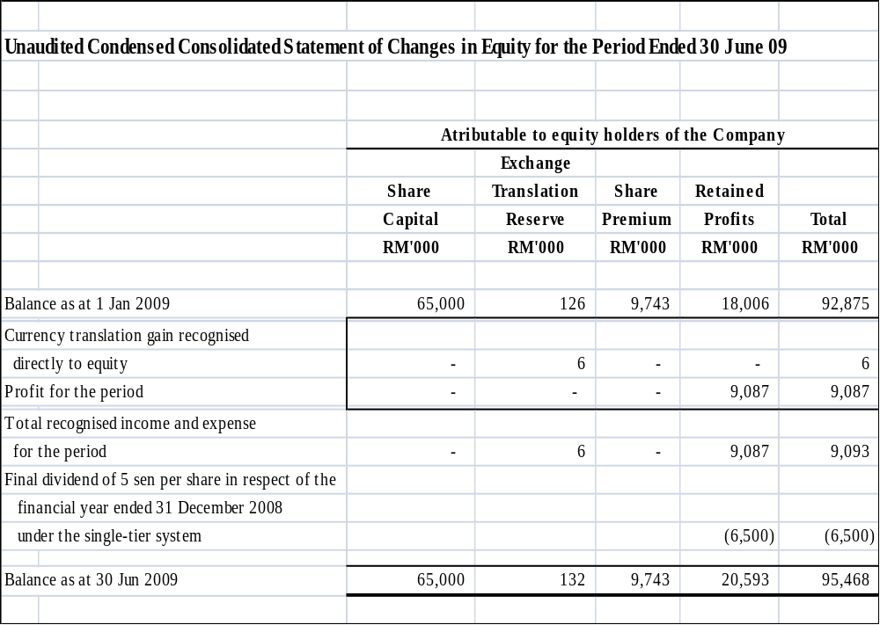

The condensed consolidated statement of changes in equity should be read in conjunction with the audited financial statements for the financial year ended 31 December 2008 and the accompanying explanatory notes attached to the quarterly financial report.

LUXCHEM CORPORATION BERHAD
(Company No: 224414-D)
(Incorporated in Malaysia)

QUARTERLY FINANCIAL REPORT AS AT 30 JUNE 2009

NOTES TO THE UNAUDITED QUARTERLY FINANCIAL REPORT

- NOTES PURSUANT TO THE FINANCIAL REPORTING STANDARD 134 (FRS 134): INTERIM FINANCIAL REPORTING

A1. Basis of reporting preparation

- The quarterly financial statements is unaudited and has been prepared in accordance with the Financial Reporting Standards 134 (FRS134):”Interim Financial Reporting” issued by the Malaysian Accounting Standards Board (“MASB”) and Appendix 9B part A of the Listing Requirements of Bursa Malaysia Securities Berhad (“Bursa Securities”).

The accounting policies and methods of computation adopted by the Group in this quarterly financial report are in compliance with the new and revised Financial Reporting Standards issued by the MASB.

A2. Auditors’ report

There was no qualification on the audited financial statements of the Company for the financial year ended 31 December 2008.

A3. Seasonal or cyclical factors

The business operations of the Group are not significantly affected by seasonal or cyclical factors during the period under review.

A4. Items of unusual nature and amount

There were no items affecting assets, liabilities, equity, net income or cash flows that are unusual because of their nature, size or incidence in the quarterly financial reports.

A5. Issuances, cancellations, repurchase, resale and repayments of debt and equity securities

There have been no issuances, cancellations, repurchases, resale and repayments of debt and equity securities during the current period and year to date

A6. Dividends paid

The Company has paid a first and final dividend of 5 sen per ordinary share in respect of the financial year ended 31 December 2008 under the single tier system on 30 June 2009.The dividend amounted to RM 6,500,000.

LUXCHEM CORPORATION BERHAD
(Company No: 224414-D)
(Incorporated in Malaysia)

QUARTERLY FINANCIAL REPORT AS AT 30 JUNE 2009

NOTES TO THE UNAUDITED QUARTERLY FINANCIAL REPORT

A7. Segmental information

Segmental results by business activities:-

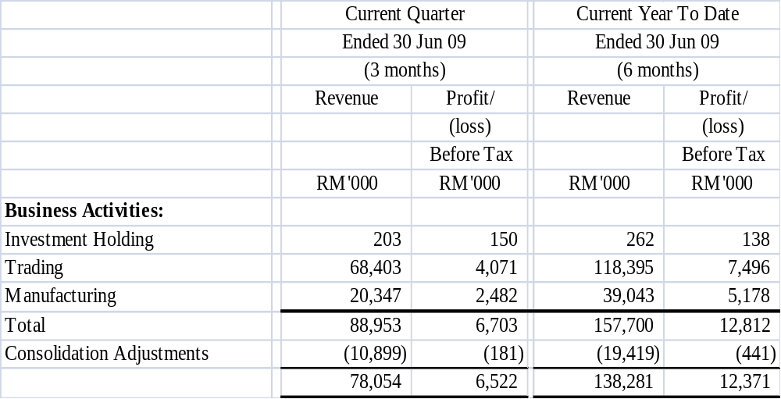

A8. Valuation of property, plant and equipment

There was no valuation of the property, plant and equipment in the current period under review.

A9. Capital commitments

Capital commitment as at end of 30 June 2009
the current quarter and financial RM’000
year to date are as follows:-

Approved but not contracted for:- 7,000

A10. Material events subsequent to the end of period reported

There were no material events subsequent to the end of the period that have not been reflected in the financial statements for the period.

LUXCHEM CORPORATION BERHAD
(Company No: 224414-D)
(Incorporated in Malaysia)

QUARTERLY FINANCIAL REPORT AS AT 30 JUNE 2009

NOTES TO THE UNAUDITED QUARTERLY FINANCIAL REPORT

A11. Changes in the Composition of the Group

There were no changes in the composition of the group during the current period and year todate.

A12. Related Party Transactions

The Company has the following transactions with the related parties during the financial quarter.

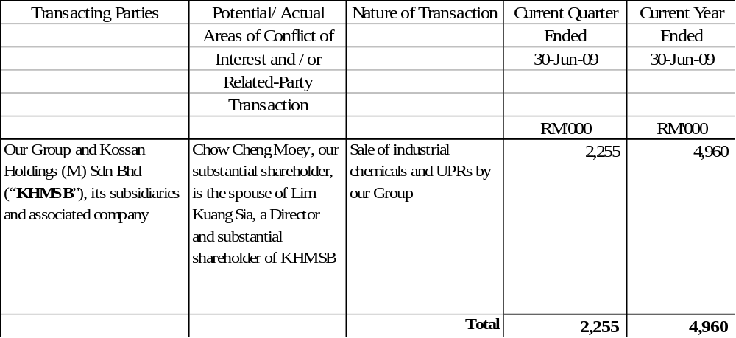
In the opinion of the directors, the above transactions have been entered into in the ordinary course of business and have been established under terms no less favourable than those transacted with unrelated parties.

LUXCHEM CORPORATION BERHAD
(Company No: 224414-D)
(Incorporated in Malaysia)

QUARTERLY FINANCIAL REPORT AS AT 30 JUNE 2009

NOTES TO THE UNAUDITED QUARTERLY FINANCIAL REPORT

- ADDITIONAL INFORMATION REQUIRED BY BURSA SECURITIES’S LISTING REQUIREMENTS

B1. Review of performance of the Company and its principal subsidiaries

For the financial year to date, the Group recorded a pre-tax profit of RM 12.37 million.

In the opinion of the Directors, the result for the current quarter and financial year to date have not been affected by any transactions or events of a material nature which has arisen between 31 December 2008 and the date of this report.

B2. Material changes in the quarterly results compared to the results of the preceding quarter

There are no material changes in the results for the current quarter compared to the results in the preceding quarter.

B3. Prospects for the current financial year

Barring any unforeseen circumstances, the Directors remain positive with the Group’s prospects.

B4. Variance between Actual Profit and Forecast Profit

The Group did not issue any profit forecast in a public document during the current financial period.

B5. Taxation

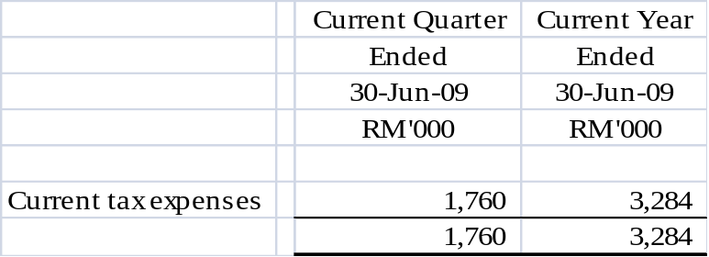

The effective tax rate of the Group for the current quarter approximates the statutory tax rate.

LUXCHEM CORPORATION BERHAD
(Company No: 224414-D)
(Incorporated in Malaysia)

QUARTERLY FINANCIAL REPORT AS AT 30 JUNE 2009

NOTES TO THE UNAUDITED QUARTERLY FINANCIAL REPORT

B6. Profit from sale of unquoted investments and/ or properties

There were no disposal of unquoted investment and properties for the current quarter and financial year-to-date.

B7. Quoted securities

During the current quarter and financial year to date, there was no purchase of quoted securities.

There was no disposal of quoted securities for the current quarter and financial year to date.

Investments in quoted securities as at 30 June 2009

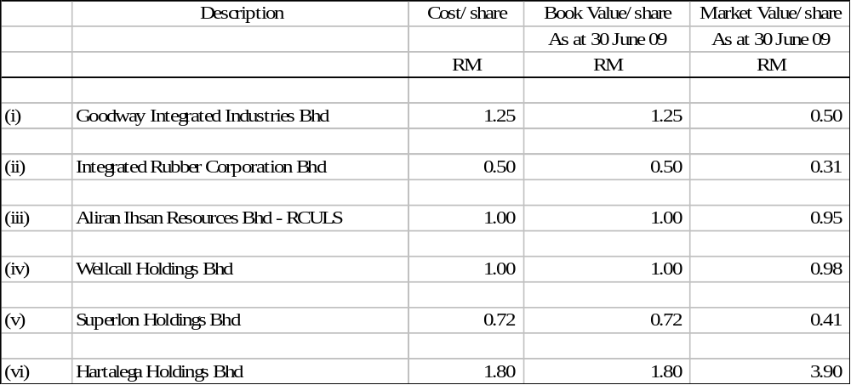

LUXCHEM CORPORATION BERHAD
(Company No: 224414-D)
(Incorporated in Malaysia)

QUARTERLY FINANCIAL REPORT AS AT 30 JUNE 2009

NOTES TO THE UNAUDITED QUARTERLY FINANCIAL REPORT

B8. Status of Utilisation of IPO Proceeds

The Public Issue was expected to raise gross proceeds of RM22.0 million, which will be utilised as follows:-

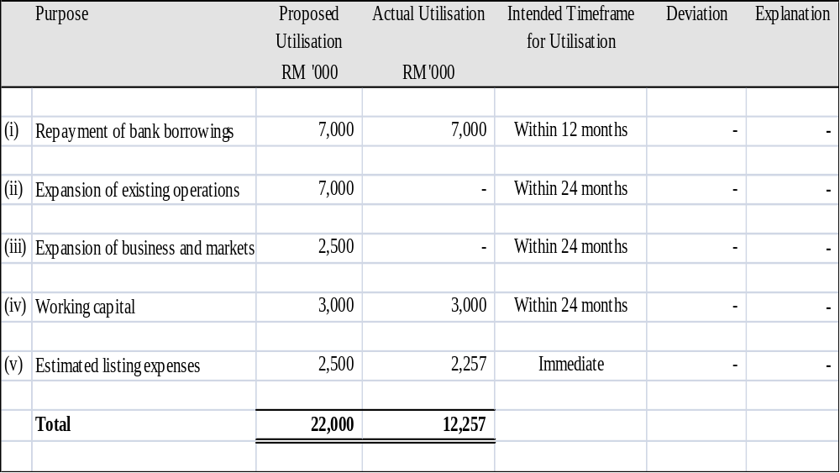

LUXCHEM CORPORATION BERHAD
(Company No: 224414-D)
(Incorporated in Malaysia)

QUARTERLY FINANCIAL REPORT AS AT 30 JUNE 2009

NOTES TO THE UNAUDITED QUARTERLY FINANCIAL REPORT

B9. Group borrowings and debt securities

The Group’s borrowings as at 30 June 2009 are as follows:-

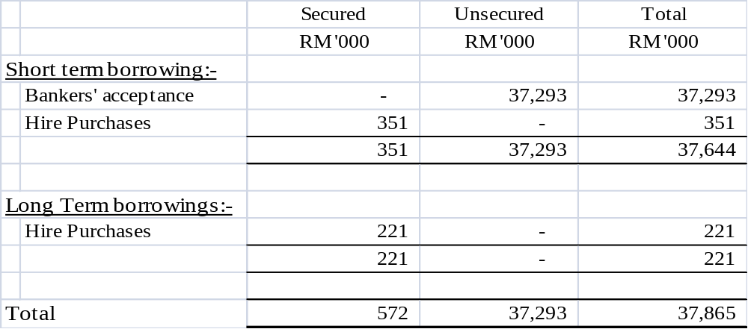

B10. Off Balance Sheet Financial Instruments

Foreign Currency Forward Contracts

Foreign currency forward contracts protect the Group from movement in exchange rates by establishing the rate at which a foreign currency asset or liability will be settled. Exchange gains and losses arising on contracts entered into are deferred until the date of such transaction, at which time they are included in the measurement of such transactions. As at 30 June 2009, the Group has foreign currency forward contracts outstanding of USD 1.743 million.

LUXCHEM CORPORATION BERHAD
(Company No: 224414-D)
(Incorporated in Malaysia)

QUARTERLY FINANCIAL REPORT AS AT 30 JUNE 2009

NOTES TO THE UNAUDITED QUARTERLY FINANCIAL REPORT

B11. Material Litigation

As at 30 June 2009, neither our Company nor any of our subsidiaries is engaged in any material litigation and arbitration either as plaintiff or defendant, which has a material effect on the financial position of our Company or our subsidiaries and our Directors are not aware of any proceedings pending or threatened or of any facts likely to give rise to any proceedings which might materially and adversely affect the financial position or business of our Company or our subsidiaries.

B12. Proposed Dividend

The Board of Directors recommends a proposed single tier interim dividend of 2 sen per ordinary share for the current quarter and the financial year to date. The entitlement date to the interim dividend shall be determined by the Board of Directors at the subsequent stage.

B13. Earnings per share

  - Basic earnings per share

The basic earnings per share is calculated based on the Group's profit attributable to equity holders of the Company of RM4.76 million for the current quarter and RM9.09 million for current financial year-to-date as at 30 June 2009 and on the number of shares in issue of 130,000,000 as at 30 June 2009.

(b) Fully diluted earnings per share

Fully diluted earnings per share were not computed as there were no outstanding potential ordinary shares to be issued as at the end of the reporting period.

By order of the Board,

Tang Ying See
Chief Executive Officer/ Managing Director
Date: 30 July 2009

